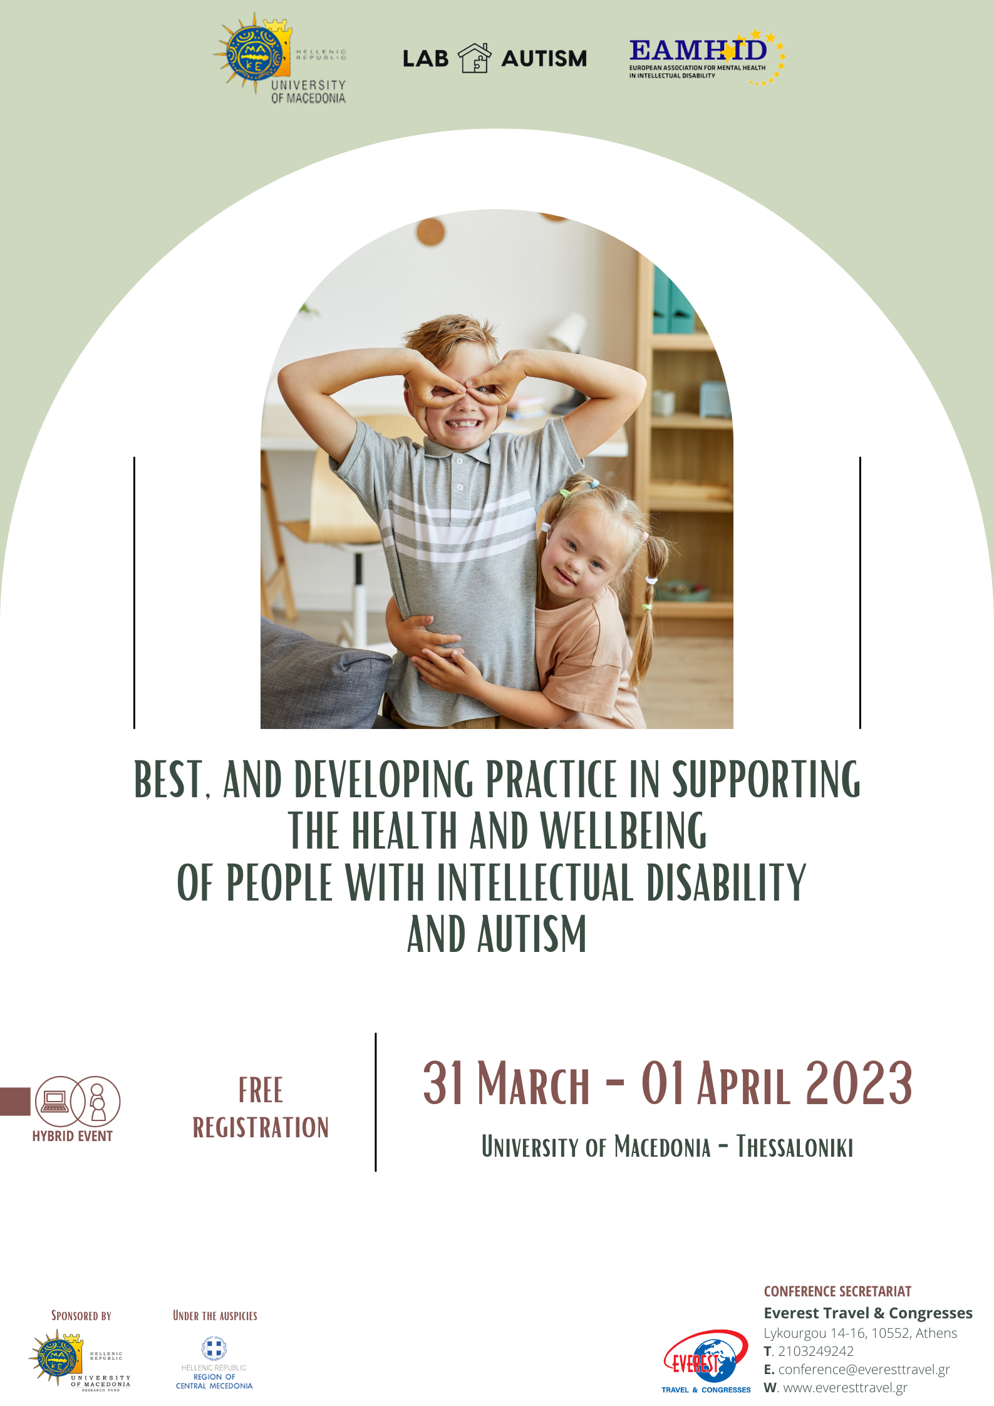
Welcome Note

Dear All,
Welcome to Masterclass under the title:"Best, and developing practice in supporting the health and wellbeing of people with intellectual disability and autism".
The Conference is taking place from March 31st to April 1st, 2023 and is organized by the University of Macedonia,Department of Educational and Social Policy, Laboratory of Autism -Developmental Spectrum Disorders and Behavior Difficulties of the Human in collaboration with the European Association for Mental Healthin Intellectual Disability in a hybrid form (with a physical presence in University of Macedonia and remotely through a link).
It is a cross-scientific, multidisciplinary event aiming to discussplanning and upgrading of the legal framework, policies and practices of the competent social institutions dealing with protection, training and rehabilitation of people with intellectual disability and autism.
Amongst the key speakers are academics from different scientific fields, researchers, professionals, politicians and and representatives of social bodies from different countries world widely.
Participants will have the opportunity to exchange their views and experiences and be updated on best, and developing practices in supporting the health and well-being of people with intellectual disability and autism.

Christine K. Syriopoulou- Delli

Associate Professor, Director of Laboratory of Autism -Developmental Spectrum Disorders and Behavior Difficulties of the Human, University of Macedonia, Department of Educational and Social Policy
Chairman of Conference Organizing Committee

Day 1 | Friday, March 31st2023

09.30-10.30 | 1st Session  Panel:C. Syriopoulou-Delli, K. Sarri, E. Gkiolnta, E. Papaefstathiou  - Opening speech  - Greetings – Welcome Addresses  - Professor Dean of the School of Information Sciences, Department of Applied Informatics, University of Macedonia / A. Chatzigeorgiou  - Professor of Social Anthropology, Head of the Department of Balkan, Slavic and Oriental Studies, University of Macedonia / F. Tsibiridou  - Innovative initiatives and interdisciplinary synergies to support people with intellectual disability and autism / M. Dermetzopoulou  - Educational Robotics and Autism Spectrum Disorders - Research data and educational practice / T. Papazoglou, C. Karagiannidis
10.30-11.45 | 2ndSession  Panel:P. Varsamis, V. Giannouli, E. Papaefstathiou, K. Sarri, Μ.E Μeligkopoulou  - Inclusive Education and [Intellectual] Disabilities: Current Trends and Challenges / A. Vlachou  - Learning design in the 21st Century School for the Holistic Approach of the ASD and intellectual Disabilities children’s Individual Educational Needs / T. Asteri  - Biological sex, Gender Identity and Autism Spectrum Disorder / P. Pervanidou  - Production of Greek singletons in adults with Down Syndrome: The case of Greek plosives, fricatives and affricates / K. Fiorentzi, A.S Antoniou  - Robots Application, Parental Involvement in Promoting Distance Learning inclusion for individuals with autism, intellectual and Developmental Disabilities / E. Gkiolnta, C. Syriopoulou-Delli
11.45-12.30 | Coffee break
12.30-13.30 | 3rd Session  Panel:A. Okalidou, I. Papavasileiou, V. Neofotistos, A. Psalti, E. Papaefstathiou  - Does Early Intervention Work? / L. Thomaidis  - Social Skills Groups in Autism: Bridging Social Functioning and Competence / R. Tzorva  - After the formal diagnose, what is next? / E. Georgiadou-Stefanaki  - Accessibility in higher education for students with intellectual and developmental disabilities including autism / C. Syriopoulou - Delli  - Discussion, Conclusions, Closing Remarks / R. Ceccotto
13.30-14.30 | Light Lunch
14.30 | Visiting Special Elementary School Developmental Rehabilitation Institute, Pefka,Thessaloniki  http://dim-eid-pefkon.thess.sch.gr/?cat=4  Director: ΚonstantinosNotas

Day 2 |Saturday, April 1st 2023

10.00-11.00 | 4th Session  Panel: A. Οkalidou, I. Papavasiliou, A. Tsirikas, A.I. Filiou, E. Gkiolnta, G. Fragoulis  - Physical activity and quality of life in individuals with autism spectrum disorder (ASD) and intellectual disability (ID) / D. Koutsouki  - A perspective on emotional needs in people with autism spectrum disorder / ElsRonsse  - Α Descriptive Study on Intellectual Developmental Disorder / J. Santambrogio
11.00-11.30 | Coffee break
11.30-12.45 | 5th Session  Panel:A. Psalti, E. Valkanos, K. Sarri, G. Fragoulis  - Virtual interactive environments and desktop touchscreens: their contribution to the teaching of co-operative skills to children with autism / G. Kalamoti,C. Syriopoulou- Delli  - The role of KEDASY in supporting the students with intellectual disability and autism / P. Stagiopoulos  - The mentalizing skills and stress regulation of persons with an intellectual disability with and without Autism and the serious game ‘You and I’ / P. S. Sterkenburg  - Schizophrenia in autistic adults with intellectual disabilities.Diagnostic assessment and interventions. Results from a nation-wide multicenter study in Norway 2010 – 2020 / T.L Bakken  - Working to deliver a national autism strategy for health services - experience from the NHS England Autism Programme / R. Banks
12.45-13.45 | Light Lunch
13.45-14.30 | 6th Session  Panel :P. Varsamis, I. Papavasiliou, A. Pampouri, E. Papaefstathiou  - Play and technological tools to enhance skills in preschool children with ASD / E. Papaefstathiou, A.I.Filiou, E. Gkiolnta, K. Sarri, C. Syriopoulou-Delli  - Parent Counseling and other Interventions to Support Parents of Pre-school Children with Autism Spectrum Disorders / E. Papaefstathiou, A.IFiliou, E. Gkiolnta, K. Sarri, C. Syriopoulou-Delli  - Parents and Siblings of Children with Autism Spectrum Disorder: A Literature Review / A. Loi,C. Syriopoulou-Delli, A.S. Antoniou
14.30 | Discussion, Conclusions and Highlights / R. Ceccotto

Speakers List

Antoniou Alexandros-Stamatios, Professor Department of Primary Education, NKUA
Asteri Theodora (Doretta), PhD. NKUA, Scientific Advisor and Coordinator of the Scientific Unit “Special and Inclusive Education” at the Institute of Educational Policies, Ministry of Education
Bakken Trine Lise, PhD , Head of research at the Oslo University Hospital
Banks Roger, National Clinical Director for Learning Disability and Autism, NHS England
Ceccotto Raymond, President of ARFIE
Chatzigeorgiou Alexander, Professor Dean of the School of Information Sciences, Department of Applied Informatics, University of Macedonia
Derks Suzanne, PhD candidate, (Lab Social relations and attachment) Vrije Universiteit Amsterdam, The Netherlands
Dermetzopoulou Μelina-Maria, Prefecture of Macedonia, Deputy Governor of Public Health and Social Solidarity Region of Central Macedonia
FiliouAreti-Irini,Psychologist, PhD candidate, University of Macedonia
Fiorentzi Krystallenia, PhD candidate NKUA
Fragoulis Georgios, Professor, Department of Electrical and Computer Engineering, University of Western Macedonia, Faculty of Engineering
Georgiadou Stefanaki Eleni, President of M.A.m.A Verias (Welfare for People with Autism)
Giannouli Vasiliki, Assistant Professor, Department of Educational and Social Policy, University of Macedonia
Gkiolnta Eleni,Special Education teacher, PhD candidate, University of Macedonia
Kalamoti Grammatiki, Primary School Teacher, MSc Special Education
KaragiannidisCharalampos, Professor University of Thessaly, Department of Primary Special Education
Koutsouki Dimitra, Professor, Laboratory of Adapted Physical Activity/ Developmental & Physical Disabilities, Faculty of Physical Education & Sport Science, National and Kapodistrian University of Athens, Greece
Loi Katerina, Speech Therapist, MSc in Special Education University of Athens
Μeligkopoulou Maria Emma, Assistant Professor , Department of Music Science and Art, University of Macedonia
Neofotistos Vasilios, Laboratory and Teaching Staff, Department of Educational and Social Policy, University of Macedonia
Okalidou Areti, Professor, Department of Educational and Social Policy, University of Macedonia
Pampouri Anastasia, Assistant Professor, Department of Edcuational and Social Policy University of Macedonia
Papaefstathiou Elpis, PhD candidate, University of Macedonia
Papavasileiou Ioanna, Professor , Department of Educational and Social Policy, University of Macedonia
PapazoglouTheodora,Educator, PhD, University of Thessaly
Pervanidou Panagiota, Associate Professor of Developmental and Behavioral Pediatrics, Head of the Unit of Developmental and Behavioral Pediatrics, First Department of Pediatrics, School of Medicine, National and Kapodistrian University of Athens, Athens, Greece. President of the Hellenic Society of Developmental Pediatricians
Psalti Anastasia, Professor, Department of Educational and Social Policy, University of Macedonia
Ronsse Els, Psychologist, member of the EAMHID NEED-group and chair of SEN-SEO
SantambrogioJacopo,PhD, Psychiatrist, ASFRA Foundation Specific Cognitive Dysfunctioning And Vulnerability to Specific Psychopathology
Sarri Kyriaki, Primary Education Teacher, PhD candidate
StagiopoulosPetros, PhD in Special Education, Supervisor in 1st KEDASY of East Thessaloniki
Sterkenburg Paula Professor, (Lab Social relations and attachment) Vrije Universiteit Amsterdam, The Netherlands
Syriopoulou-Delli Christine,Associate Professor, University of Macedonia, Department of Educational and Social Policy, Director of Laboratory of Autism -Developmental Spectrum Disorders and Behavior Difficulties of the Human
Thomaidis Loretta, MD, PhD Professor of Developmental Pediatrics, National and Kapodistrian University of Athens
Tsimbiridou Fotini Professor of Social Anthropology, Head of the Department of Balkan, Slavic and Oriental Studies, University of Macedonia, Anastasia Pampouri, Assistant Professor , Department of Educational and Social Policy, University of Macedonia
Tsirikas Athanasios, Laboratory and Teaching Staff , Department of Educational and Social Policy, University of Macedonia
Tzorva Rebecca,M.A., Speech Language Pathologist
Valkanos Efthimios, Professor, Department of Educational and Social Policy, University of Macedonia
Varsamis Panagiotis, Assistant Professor, Department of Educational and Social Policy, University of Macedonia
Vlachou Anastasia, Professor of Inclusive Education, Department of Educational Studies, National and Kapodistrian University of Athens, Greece
Willemen Agnes, Associate Professor(Lab Social relations and attachment)Vrije Universiteit Amsterdam, The Netherlands

Acknowledgments

The Organizing Committee would like to express their sincere gratitudeto the following sponsors for their support:

