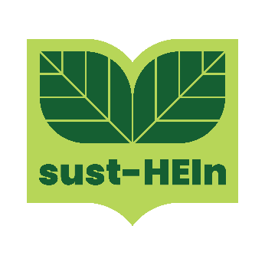
INFO DAY PRESS RELEASE

Info Day on Fostering a Whole Institution Approach in Higher Education Sustainability through Systems Thinking

Thessaloniki, [30/06/2023] – University of Macedonia is excited to announce an upcoming Info Day dedicated to fostering a whole institution approach in higher education sustainability through systems thinking. This event, scheduled for June 30, aims to bring together academic professionals, industry experts, and stakeholders to be informed about the SUST-HEIn project, its objectives, and benefits for the Higher Education Institutions. SUST-HEIn project aims to foster a whole institution approach in Higher Education sustainability through systems thinking.
Sustainability has become a critical global issue, and higher education institutions have a unique role to play in shaping a sustainable future. By adopting a whole institution approach and integrating systems thinking into their operations, universities can effectively address environmental, social, and economic challenges while nurturing a culture of sustainability among students, faculty, and staff.
This Info Day will feature a diverse range of presentations related to the objectives of the project and what outputs the project will have and knowledge exchange through discussion and networking session. Attendees will have the opportunity to engage with leading experts in the field, share best practices and collaborate on innovative solutions.
Key topics that will be covered during the event include:
- Project Objectives and Management
- Mapping and review of the state of the art of institutional sustainability self-assessment models and tools and integration of systems thinking and modelling
- Development of a whole-system sustainability model
- LCU’s actions on Agenda2030’s SDGs and role in the SUST-HEIN pilots
- Erasmus European experiences and sustainability

The Info Day on Fostering a Whole Institution Approach in Higher Education Sustainability through Systems Thinking is open to academic professionals, university staff, students, sustainability officers, administrators, researchers, and industry representatives passionate about sustainability in higher education.

To learn more about the agenda and speakers, please visit https://www.facebook.com/events/278810654645810/278810664645809/?ref=newsfeed

Join us at University of Macedonia on June 30 to unlock the potential of systems thinking and shape a sustainable future for higher education. Together, we can make a significant impact on our institutions, communities, and the world.

