International ReflectiON Of Disability in Art Festival

OPEN INCLUSIVE PHOTOGRAPHY COMPETITION

The International "Reflection of disability in art" Festival (iRoDi), as an institution of the University of Macedonia and as a unit for the Support of Social Inclusion through Art of the Laboratory of Applications of Educational and Social Inclusion of People with Learning and Adaptation Difficulties (LAESI), invites all people with or without disability to participate in an open photo inclusive competition on the theme "My moments are…".

The action is implemented in collaboration (alphabetical) with the Center of Special Education Thessaloniki, the Down Syndrome Association of Greece, the Greek Society for the Protection of Autistic People (Thessaloniki Branch) and the Municipality of Neapoli-Sykies – Municipal Common Benefit Enterprise for Service of Neapoli-Sykies and offers an opportunity to express the creativity of disabled and no disabled people through Art.

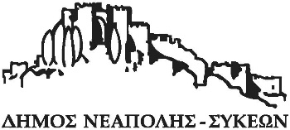

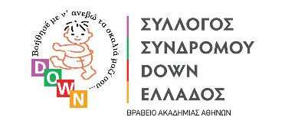

Terms of participation
A. Photographs

- The photographs considered to be of outstanding quality will be included in the Inclusive Photography Exhibition and other related events of the Art Program of the 6th International "Reflection of disability in art” Festival.
- Participation is open to all people, who have reached the age of 18.
- Every photographer will submit one (1) photograph which
  - is accompanied by:
- The contact details of the photographer or the organization he represents,
- Short biography up to 200 words of the photographer and presentation of the organization
- A description of the photo up to 200 words.
- In case of depiction of persons, confirmation of their consent to be attached to the submission e-mail (see below).
  - Meets the following technical specifications:
- Minimum size of 8 Mpixels,
- Jpeg file format
- little technical post-processing

Submissions that do not meet all of the above conditions are automatically excluded.

4. The deadline for submission of applications for participation in the Photography Competition is the 19th April 2024.
5. Photographs should be submitted to rod@uom.edu.gr .
B. PANEL OF JUDGES
The photographs submitted will be judged by a panel of photography experts.

C. QUALIFICATION for the exhibition
Participants whose photographs qualify for the exhibition will be notified by the University of Macedonia as to the exhibition program as well as the remaining festival events.

D. OTHER TERMS
1. The submission of photograph automatically implies the full acceptance of these terms and an affirmation of the truth and accuracy of the data.
2. The photographs submitted will remain in the University of Macedonia archives and will be used for educational purposes.
Participants submitting photographs concede to the University of Macedonia the non-exclusive right to publish them for promotional purposes.
3. The University of Macedonia reserves the right to publish information accompanying qualifying photographs.
Contact information
University of Macedonia
Department of Educational and Social Policy
Cc Lefkothea Kartasidou
156, Egnatia Str., GR- 54636
Thessaloniki
Tel. 0030 2310891350
E-mail: rod@uom.edu.gr

