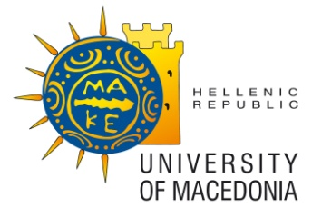 | 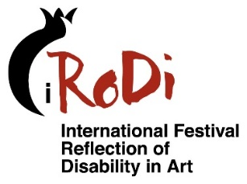 | With the support

6th INTERNATIONAL FESTIVAL
REFLECTION OF DISABILITY IN ART

DECEMBER 1-8, 2024

OPEN CALL

The International Festival "Reflection of disability in art" (iRoDi Festival), invites the interested parties to send their work to join in the program of the 6th Festival that will be held in Thessaloniki. Greece, December 1 to 8, 2024.
The purpose of the festival is to highlight art through the perspective of disability. The idea starts from the inalienable right of people with disabilities to express themselves through art either amateur or professional. The festival is meant to reflect the skills of people with disabilities and the opportunities that each society has to provide to each individual, contributing to the cultural identity of the individual and society.

Terms of participation

1. Films
The films to be included in the program of the 6th International Festival "REFLECTION OF DISABILITY IN ART" must meet the following conditions:

a) Relevance to the content of the Festival and contribution to the promotion of the concept of self-determination, educational and social inclusion, quality of life, independence and the emancipation of disabled people.
b) Final projection shots are available in DCP, Apple ProRes, h264 or MPEG4.
(c) Acceptable types: all
(d) Duration up to 60’
(e) These films should have English or/ and Greek subtitles.

These films if possible need to be featured with an audio description [AD: Audio Description] for visually impaired people and with subtitles [SDH: Subtitles for the Deaf and Hard-of-Hearing] for hearing impaired people.

2. APPLICATION FOR PARTICIPATION
(a) The deadline for the submission of the application is May 31, 2024.
(b) The application shall be accompanied by:

- A digital copy of the film, under the conditions of the 1st Term of this Invitation,
- A photograph of the movie (format: jpeg or tiff 300 * 300dpi),
- Subtitles (English and/or Greek) in a form of srt file
- A summary of the film's case of up to 150 words,
- In case of submission by a body, a description of the body’s activity up to 500 words,
- The director’s biography,
- Completed list of information as follows:
- year of production,
- format,
- duration,
- director,
- producer,
- editing,
- music,
- coefficients, specifically identifying disabled persons, their disability and their occupation with art,

and is being submitted via FilmFreeway

Alternatively, the creators can submit their work:

- via other electronic applications, such as, dropbox, wetransfer, etc.

or

- by mail to:

University of Macedonia,
Dpt of Educational and Social Policy
Prof Lefkothea Kartasidou
156 Egnatia st., GR-546 36,
Thessaloniki, Greece
With the label:
For the 5th International Festival "REFLECTION OF DISABILITY IN ART"

The Organizing Committee shall take special care so as to enable all applications to be submitted, and to resolve any problems that may arise.

c) Submission of an application automatically means the unconditional acceptance of these terms and is a responsible statement of the truth and accuracy of the submitted data.

d) The copies of the submitted films remain in the archives of the University of Macedonia and are used for educational purposes.

3. SELECTION PROCEDURE
The qualification of the films is made by a group of people - specialists in cinema, arts, disability studies and special education.

4. PROVISION
The University of Macedonia will inform applicants in writing of the final selection, projection planning, etc.

5. OTHER TERMS
a) Issues of rights and permissions are the responsibility of the individual applying. The University of Macedonia has no responsibility for them.
b) The University of Macedonia reserves the right to publish details of the film, including the contact details of the director and producer.
(c) The costs of sending an application and material to be selected shall be borne by the applicant. The University of Macedonia undertakes the costs of returning and insuring the material while it is in its possession.

Contact

University of Macedonia
156 Egnatia str., GR- 546 36
Thessaloniki, Greece
Contact Phone: +30 2310 891350
E-mail: rod@uom.edu.gr

